Partner Central Image Request Form

This sheet Must accompany all products being sent to Partner Central when requesting Imaging Services. Our photographers will image your products to all style guide standards, ensuring accurate, consistent, high quality images. Please ship samples via DHL, FedEx or UPS, please do not send by USPS.

Storefront Name:___________________________________ Submission Date: _________________
Seller Company: _______________________________________________________________________
Seller Contact Name: ___________________________________________________________________
Product Return Address:_________________________________________________________________
_____________________________________________________________________________________
Contact Phone: __________________________ Contact Email: __________________________
Carrier Acct #: __________________________Return samples via, please select: UPS, FedEX or DHL
Total Number of Items to be Imaged: ________ (list Items on next page)

Photography Options:

$18 - Jewelry images - standard 3 image set
$25 - Jewelry Sets - suite with multiple pieces
$10 - Jewelry 360 photography
$10 - Gemstone - standard 3 image set
$10 - Gemstone 360 photography (available for stone larger than 10mm or 2ct.)
$10 - Gemstone Sets
$10 - Gemstone Parcels
$25 - Watches - standard 3 image set
$15 - Watch 360 photography
$10 - Model close-up shots (ear, hand, neckline and wrist)

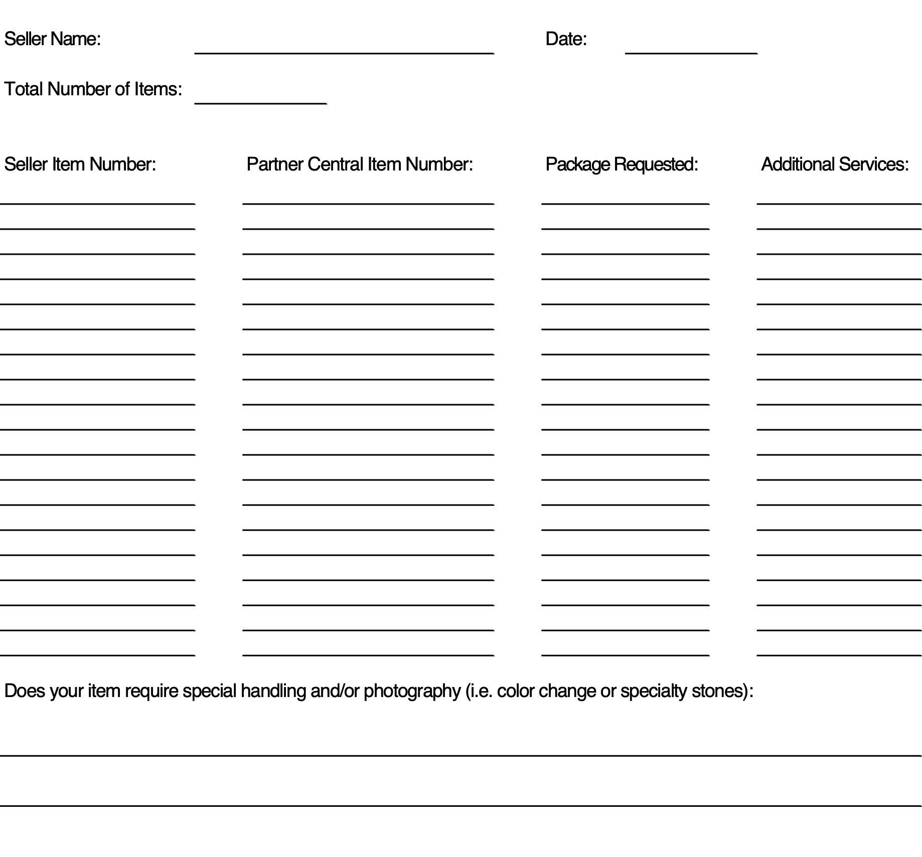

Shipping address: Jedora
Attn: Imaging Requests
210 Hayfield Road
Knoxville, TN 37922

